# Proposal On League Manager

## Susan Gurung Submitted to: Niman Maharjan

## 00174423

## Computing Project

## Batch: 22B

Contents

Chapter 1: Overview 2

1. Introduction 2

2. Background 2

3. Description 2

Chapter 2: Scope of the project 3

1. Scope 3

2. Aims 3

3. Limitation 3

4. Objectives 3

5. Overview of the project 3

Chapter 3: Development Methodology 4

1. Waterfall model 4

2. Design pattern 5

3. System architecture 6

Chapter 4: Project planning 6

1. Work Breakdown Structure 6

2. Milestone 6

3. Scheduling 7

3.1 Time estimation 8

3.2 Gantt Chart 8

Gantt Chart 9

Chapter 5: Risk Management 10

Chapter 6: Configuration management 12

Chapter 7: Conclusion 13

# Figure Table

1. Waterfall model
2. Design Pattern
3. WBS
4. Time estimation
5. Milestone
6. Time estimation
7. Gantt Chart

# Chapter 1: Overview

## Introduction

League manager is a project I have choose to work on. It can be a very reliable means of organizing a competitive football league. With this, there will be less error in the league and everything will be free fair and transparent as well. It mainly focuses on league system rather than the knockout competitive tournaments. It can help you with time management and the use of paper and pens as well.

## Background

Football is the most loved and played game in the world. The love and passion for it has never decreased and neither will it. Every country has a league of its own. To organize a league it is very messy work. Data can be lost misused and hard to handle. So League organizer can help people a lot in organizing a league.

## Description

The reason why this project is done is to eradicate the problems we have while organizing a league using pen and a paper. League can take a lot of time so managing them is a really hard work but no more with this project. The old days are gone.

The expected features of this project are:

1. Organizer can add description about team.
2. They can add teams and players.
3. They can properly add details about players.
4. The table will be updated automatically.
5. Players with cards will be stored as well as goals.
6. Players will be banned as per the rule.
7. Fixtures can be shown easily.
8. Champions will be declared automatically.

# Chapter 2: Scope of the project

## Scope

Scope is that part of project, which involves detailed information about the project such as goals, task, features etc. Documentation explains boundaries of the project as well as procedures and establishes responsibility for team members.

## Aims

* 1. Easy to manage leagues.
  2. Easy to use.
  3. Less error

## Limitation

1. It is not errorless.
2. It hasn’t reached its full potential
3. Many further features could be added.
4. The user interface may not be applicable for everyone.

## Objectives

To meet the aim of the project objectives are listed below:

1. To organize a league properly.
2. To automate the results.
3. Easy to use application.
4. View results and fixtures.
5. To view players detain in the league.
6. To have an automated table.

## Overview of the project

The limitation of this project is that it is only a league-based project rather than other type of project like knockout competition and it focuses on football only not other type of sports. It is very easy to use and very reliable too. It is quick and automated which removes the traditional way of organizing a league.

# Chapter 3: Development Methodology

## Waterfall model

For our project to be a successful, we need to follow development methodology because it develops a project systematically in a serial way rather than in a messy way.it can help our project to be more productive and helps in time management as well. Among all the development methodology like waterfall and agile I have chosen waterfall Methodology for this project.

Waterfall method is that type of model in which we move on to another process after the completion of the current process. Because our requirements are known already and we do not have any further change in the requirement cause the project is short as well which means we do not have any ambiguous requirement . This method has very little amount of disadvantage when used in cases like ours.

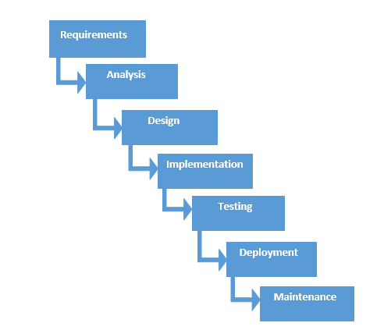

Figure 1: Waterfall model

Some advantages of waterfall model are:

1. It is easy to understand and use.
2. It is easy to manage due to strictness of the model.
3. Each step once completed and processed at a time.
4. Best for small projects.

Disadvantage of waterfall model are:

1. Not suitable for project where requirement are not defined properly.
2. It does not work better complex projects.
3. There is high amount of risk and uncertainty.
4. There is no going back after completion of a stage as it is very difficult.

## Design pattern

I have used MVC deign pattern for this project. It is the most popular framework for software development nowadays as it can be applicable for both web-based and desktop applications.

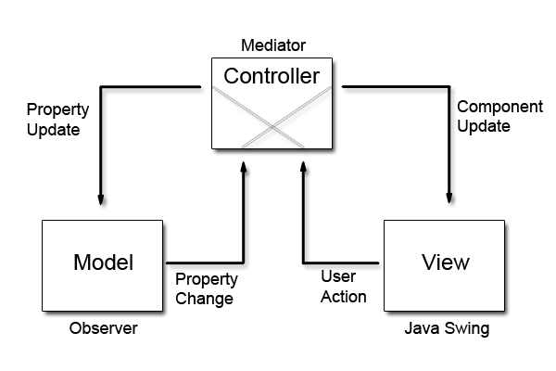

Figure 2: Design Pattern

Model: it is responsible for data that user works and represents the data between view and controller

View: it is responsible to handle UI of the application.

Controller: It acts as the main point between model and view as it handles the changes and requests.

## System architecture

The Arm system architectures define components and interfaces that make it easier for hardware and software to interoperate. (System Architectures, 2017)

# Chapter 4: Project planning

## Work Breakdown Structure

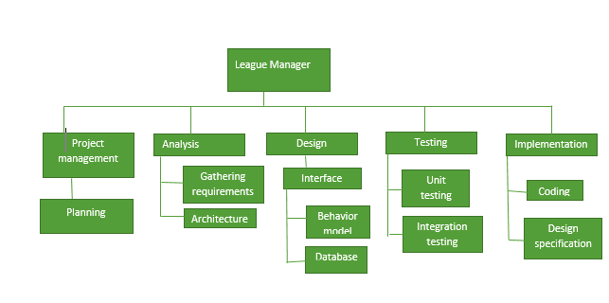

Figure 3: Work Breakdown Structure

Work break down structure is used to break down the project properly into manageable components. It helps us to assign responsibility, estimate cost, time risk, and difficulties. It also show the serial steps to be done while doing the project. In the above figure, I have shown how main task are divided into small tasks.

## Milestone

|  |  |  |
| --- | --- | --- |
| **WBS** | **Task name** | **Days** |
| 1 | **Project management** | **16 days** |
| 1.1 | Planning | 16 days |
| 2 | **Analysis** | **28 days** |
| 2.1 | Requirements | 20 days |
| 2.2 | Architecture | 8 days |
| 3 | **Design** | **25 days** |
| 3.1 | Database | 5 days |
| 3.2 | Interface design | 15 days |
| 3.3 | Behavioral design | 5 days |
| 4 | **Implementation** | **20 days** |
| 4.1 | Coding | 15 days |
| 4.2 | Design specification | 5 days |
| 5 | **Testing** | **7 days** |
| 5.1 | Integration testing | 4 days |
| 5.2 | Unit testing | 3 days |
| 6 | **Final Documentation** | **12 days** |
|  | **Total** | **108 days** |

### Figure 4 : time estimation

|  |  |  |
| --- | --- | --- |
| **S.N** | **Milestone** | **Date** |
| 1 | Proposal | 25th March, 2019 |
| 2 | Analysis | 10th April, 2019 |
| 3 | Design | 9th May, 2019 |
| 4 | Implementation | 4th June, 2019 |
| 5 | Testing | 25th June, 2019 |
| 6 | Documentation | 2nd July, 2019 |

Figure 5: Milestone

## Scheduling

A Gantt chart is a horizontal bar chart developed as a production control tool in 1917 by Henry L. Gantt, an American engineer and social scientist. (Rouse, 2007) The advantage of Gantt Chart is that it shows the proper progress of the project properly. It shows detailed information about the tasks. It can also show the information in a diagram form. The Gannt chart for my project is shown below:

## Time estimation

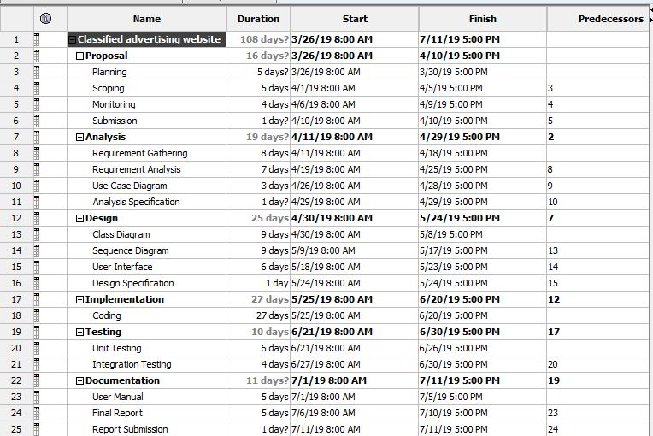

Figure 6: Time estimation

## Gantt Chart

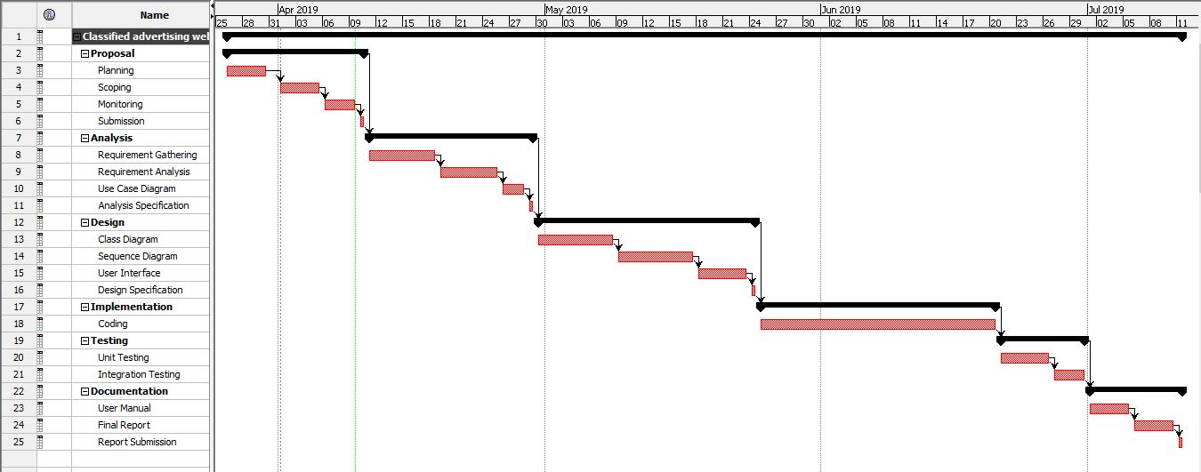

Figure 7: Gantt Chart

# Chapter 5: Risk Management

Risk management means identifying the risk that may occur during the project, which can harm the productivity of the project and cause different obstacles that can affect our project. If not analyzed properly it we may not be able to complete our project on time. It is very important as it can help us prepare for the upcoming risk that occur in the project because risk can affect our project and solution for every risk should be there.

1. Identify the risk

This step shows or list out the risk that can occur during the project. All the possible risks should be listed. We can learn to how to deal with those type of problems or prevent ourselves from having that problem.

1. Analyze the risk

When all the risk are listed out and identified properly, we have to decide the likelihood and consequences it brings. We should understand the nature of the risk and how it affects the project.

1. Evaluate risk

In this process we determine the likelihood and consequences of the risk that results to the magnitude of the risk and then rank them. We have to decide if the risk is acceptable or not.

1. Treat the risk

In this step we determine how we can handle the highest ranked list and have a plan to stop those risks.

1. Monitor the risk

Here we see how the risk has affected the project by monitoring, tracking and reviewing the risk.

The table for likelihood and consequences of the risk we have created a table and given value as per their impact:

|  |  |
| --- | --- |
| **LIKELIHOOD** | **VALUE** |
| LOW | 1 |
| MEDIUM | 2 |
| HIGH | 3 |

|  |  |
| --- | --- |
| **CONSEQUENCES** | **VALUE** |
| VERY LOW | 1 |
| LOW | 2 |
| MEDIUM | 3 |
| HIGH | 4 |
| VERY HIGH | 5 |

The impact is calculated as per the likelihood and consequences multiplied together:

|  |  |  |  |  |  |
| --- | --- | --- | --- | --- | --- |
| **S.N** | **Risk** | **Likelihood** | **Consequences** | **Impact** | **Action** |
|  | Crashing Of Hard Disk | 1 | 4 | 4 | Using online storage system. |
|  | Natural Disasters | 1 | 3 | 3 | Having different type of storage type. |
|  | Time management | 2 | 3 | 6 | Follow our schedule properly as shown in the gant chart. |
|  | Unqualified  employee | 2 | 3 | 6 | Providing proper training |
|  | Improper analysis | 1 | 5 | 5 | Spend time properly and wide thinking. |
|  | Lack of experience | 2 | 3 | 6 | When the project is started we should do it properly. |
|  | Lack of resources | 1 | 2 | 2 | We should have our resources ready before the project starts cause it may have stop the project. |
|  | Diseases | 2 | 3 | 6 | There should be healthy eating so that I can complete all project on time. |

# Chapter 6: Configuration management

Configuration management means managing the configuration of all the project’s key products and assets. (Wrike, 2016) This includes the finished product that will be up for sale or delivered to the customer. Any changes that happen must be observed as well as measured to determine the impact on project. GitHub is used for storage of data as it can act as a regular backup as it can be used for recovery in case of some failures during the project.

# Conclusion

To conclude that even if this is a small project it can be very helpful and can work in many places. The problems and mess we had to face are no more with this software and it is automated so there cannot be any changes as per the wish of the people. It can be used many times and we can have the same results. For completion, I have used my knowledge to make my software best as I can make.

# Bibliography

(2016). Retrieved from Wrike: https://www.wrike.com/project-management-guide/faq/what-is-configuration-management-in-project-management/

Rouse, M. (2007, May). Retrieved from Search SoftwareQuality: https://searchsoftwarequality.techtarget.com/definition/Gantt-chart

*System Architectures*. (2017). Retrieved from Developer arm: https://developer.arm.com/architectures/system-architectures